Inebura

Credit Limit Prediction Model
Feature Requirement Document
Requirements for the external model development and handover team
STATUS  Proposed | OWNER  Tanserv Product | LAST UPDATED  10 September 2026
Authors | Tanserv Product Team
Reviewers | Tanserv Product, Risk, Data Engineering, Platform Engineering and the external model team
Related reference | Inebura Credit Limit Management design interface
Scope | Prediction model, real-time inference contract, validation, handover and controlled pilot requirements

1. Executive Summary
Inebura requires a model that converts payment behavior into a defensible recommended credit limit and a dynamic credit score for each ERP customer account. The model will use the account's payment history with the current client together with matched history for the same customer across other participating clients. It will also simulate how a higher or lower limit changes the score and the sixteen impact metrics used in the Credit Limit Management design.
The external model team is responsible for feature engineering, training, validation, a real-time inference service, reproducible delivery artifacts and the first production-ready model. Tanserv will supply normalized model-ready data, host the service, integrate it with Inebura and own retraining after handover. Model outputs are advisory evidence for client administrators; they do not automatically change a customer's active credit limit.

2. Problem Statement and Business Objective
Credit-limit decisions are currently dependent on manually interpreted payment history and may not consistently account for recent behavior, deterioration, cross-client evidence or the effect of changing exposure. The same customer can exhibit different payment behavior with different clients, so the model must preserve the current-client relationship while using matched evidence from other participating clients as additional context.
The objective is to provide a repeatable, explainable and timely estimate of a prudent credit limit, a 0 to 100 credit score and a ninety-day view of the consequences of an administrator-selected limit. The result must make the evidence visible without revealing another client's identity or raw commercial data.

3. Goals and Scope Boundaries
Goals | Out of scope
Predict one exact recommended credit limit in INR for an eligible ERP customer account. | Building or redesigning the Inebura Credit Limit Management user interface.
Return a dynamic 0 to 100 credit score in which a higher score means safer repayment behavior under the evaluated limit. | Authorizing users, approving changes or persisting the administrator's final limit decision.
Return confidence, risk classification and understandable contributing factors. | Cleaning raw database dumps or spreadsheets before Tanserv declares the data model-ready.
Predict ninety-day current and proposed-limit values for all sixteen approved impact metrics. | Synchronizing saved limits to ERP, accounting or customer systems.
Use matched same-customer history across participating clients while protecting source-client confidentiality. | Using anonymized peer cohorts when the same canonical customer is not matched across clients.
Provide a deterministic, versioned real-time API that Tanserv can host and operate. | Operating production retraining indefinitely after the agreed handover period.

4. Ownership and Responsibilities
Party | Required responsibility | Acceptance evidence
Tanserv Data Engineering | Provide normalized, deduplicated, quality-checked and identity-linked model-ready data with lineage and freshness markers. | Approved feature schema, data-quality report and test payloads
External model team | Design features; train, validate and explain the model; deliver the API container, code, artifacts, tests and operating documentation. | Reproducible build, validation pack and passing acceptance suite
Tanserv Platform Engineering | Host the container, secure the API, manage secrets, monitoring, deployment, rollback and production capacity. | Deployment and operational-readiness evidence
Inebura product team | Supply current and proposed-limit context, display predictions and retain the administrator's decision separately from model output. | Integration and business UAT results
Product and Risk reviewers | Approve score meaning, model quality thresholds, pilot readiness and conditions for wider release. | Recorded sign-off before pilot and general availability

5. Data Requirements and Customer Matching
Tanserv is the source of the inference payload. The external team must not build production dependencies on source-specific database or spreadsheet layouts. Input will be expressed through a versioned model-ready schema and will contain current-client history plus matched history for the same canonical customer from other participating clients.
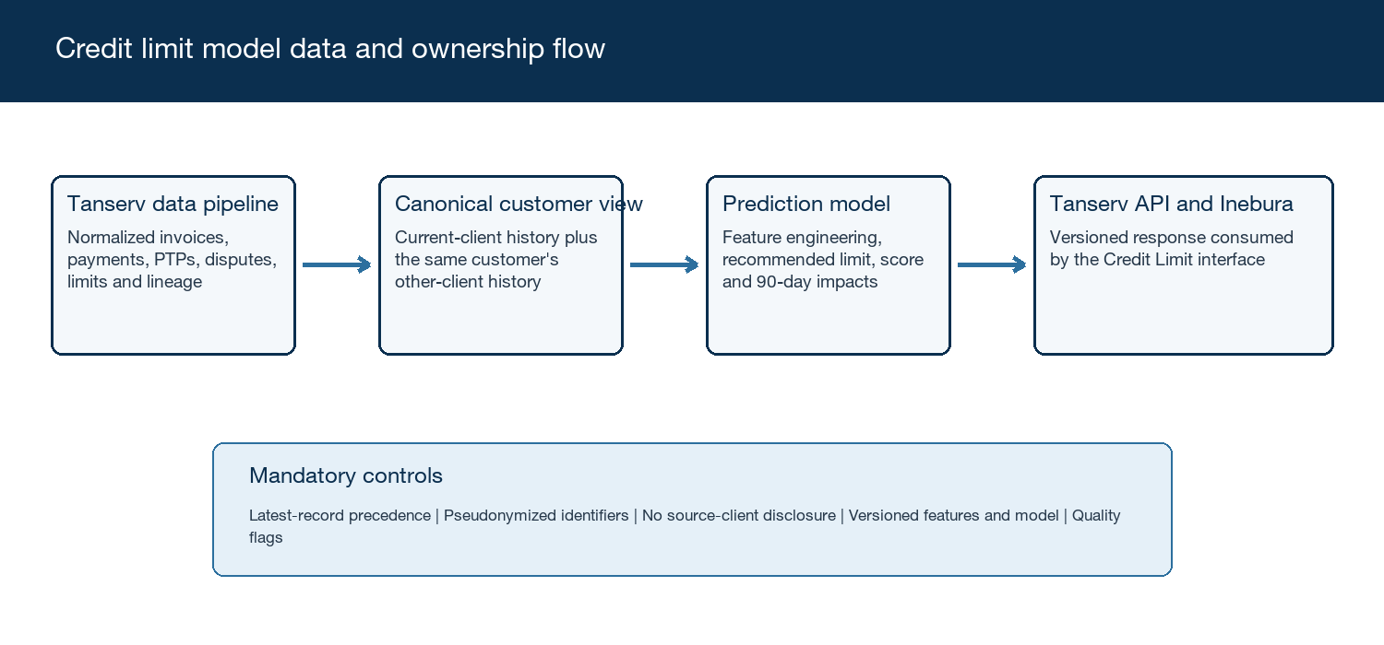
Figure 1. Credit limit model data and ownership flow

5.1 Required data domains
Domain | Minimum model-ready content | Business rule
Identity and account | Pseudonymized tenant ID, ERP account ID, canonical customer ID, active status and relationship start date | Predictions are produced per ERP account; the canonical ID enables same-customer matching
Invoices | Pseudonymized invoice ID, invoice and due dates, original amount, outstanding amount, status and update time | Amounts are INR; the latest timestamped version of a duplicate record wins
Payments | Payment and allocation dates, paid amount, linked invoice, days to payment and days past due | Partial payments and reallocations must remain reconstructable
Promises to pay | Promise date, promised amount, due date and met, pending or broken outcome | Broken PTP behavior is retained as a dated event
Disputes and adjustments | Dispute status and dates, credit notes, advances, PDC or other offsets when available | Do not infer a settled balance from an unresolved adjustment
Credit-limit history | Old limit, new limit, effective time and change reason where available | The active limit at the request as-of time must be unambiguous
Write-offs and recovery | Write-off, reversal and recovery events with amount and date | Reversals must not be counted as new write-offs
Lineage and quality | Source update time, ingestion ID, feature-schema version, freshness and quality flags | Conflicts use latest-record-wins and remain traceable

5.2 Cross-client combination rules
DR-001 Same-customer scope. Only histories mapped to the same canonical customer may be combined. Peer or look-alike customer records are not a required input.
DR-002 Relationship preservation. The current-client relationship must remain identifiable to the model so it can learn the appropriate weighting instead of treating every client relationship equally.
DR-003 Confidentiality. The response and explanations must not reveal source-client names, tenant identifiers, invoice details, balances or relationship-specific history from another client.
DR-004 Participation control. Only data from clients covered by Tanserv's approved participation and data-use controls may enter the combined history.
DR-005 Minimum evidence. The external team will propose and validate the minimum number, recency and completeness of observations required for a score. Accounts below that threshold return INSUFFICIENT_DATA.

6. Prediction Requirements
PR-001 Recommended limit. Return one exact, non-negative INR amount. The model must not round to a fixed increment and must document the objective and constraints used to define a prudent limit.
PR-002 Dynamic credit score. Return a score from 0 to 100, where higher means safer. The score must reflect combined repayment risk under the evaluated limit and the ninety-day horizon.
PR-003 Combined risk. The score must consider payment delays, delinquency, broken PTP behavior, aging deterioration and write-off behavior; the model team must document how these outcomes are combined and calibrated.
PR-004 Scenario simulation. A request without a proposed limit returns the recommended limit and current-limit scenario. A request with a proposed limit returns both current and proposed scenarios using the same as-of data and pinned model version.
PR-005 Impact outputs. Return current and predicted values, absolute and percentage change, favorable or adverse direction, unit and source type for every approved impact metric. Predicted values use a ninety-day horizon.
PR-006 Confidence and explanation. Return an overall confidence value, confidence band label, reason for low confidence and the leading positive and negative drivers. Explanations must be understandable to a credit or collections professional.
PR-007 Observed versus predicted. Each output must be labelled OBSERVED, DERIVED or PREDICTED. Confidence is required for PREDICTED values and must not be fabricated for observed facts.
PR-008 Determinism. Identical validated inputs, feature schema and model version must produce identical outputs.
PR-009 No-score result. Insufficient evidence must return a structured INSUFFICIENT_DATA status, missing-data reasons and the evidence threshold that was not met. It must not return a provisional score or recommended limit.
PR-010 Advisory status. Predictions are decision support. The model does not approve, reject or persist a credit-limit change and must not describe an outcome as guaranteed or causal.

7. Impact Metric Dictionary
For every scenario, the response must use stable metric identifiers and distinguish the current basis from the ninety-day prediction. Monetary values are INR. Percentage fields use numeric values from 0 to 100 unless a signed change is explicitly stated.
ID | Metric | Current basis | Ninety-day scenario | Unit and interpretation
payment_history | Payment History | Observed average days overdue and payment pattern | Predicted average days overdue during the horizon | days; lower is better
utilisation | Utilisation Level | Outstanding divided by active limit | Predicted horizon outstanding divided by the evaluated limit | % ; lower is safer
order_volume | Order Volume | Recent invoiced or approved order value | Expected invoiced or order value during the horizon | INR; context dependent
overdue_ratio | Overdue Ratio | Overdue amount divided by outstanding | Predicted overdue amount divided by predicted outstanding | % ; lower is better
customer_tenure | Customer Tenure | Months since the current-client relationship began | Deterministic tenure at the horizon end | months; context
broken_ptp | Broken PTPs | Recent dated broken promise-to-pay count | Expected broken PTP count during the horizon | count; lower is better
disputes | Number of Disputes | Current and recent dispute count | Expected open or new dispute count during the horizon | count; lower is better
aging_velocity | Aging Velocity | Recent monthly change in weighted receivable age | Expected monthly change during the horizon | days/month; lower is better
past_due_trend | Past Due Trend | Current improving, stable or worsening direction | Predicted direction at the horizon end | enum; improving is better
on_time_ratio | On-time Payment Ratio | Share of eligible invoices paid on or before due date | Predicted on-time share for horizon invoices | % ; higher is better
average_payment_days | Average Payment Days | Average invoice-to-full-clearance duration | Predicted clearance duration for horizon invoices | days; lower is better
delay_probability | Probability of Delay | Not applicable when no approved prior model value exists | Probability of material payment delay during the horizon | % ; lower is better
writeoff_probability | Probability of Write-off | Not applicable when no approved prior model value exists | Probability of a material write-off during the horizon | % ; lower is better
dso_change | Change in DSO | Recent signed percentage change in DSO | Predicted signed DSO change against the current baseline | % signed; lower is better
exposure_previous_limit | Exposure versus Previous Limit | Outstanding as a percentage of the immediately preceding active limit | Predicted outstanding as a percentage of that prior limit | % ; lower is safer
six_month_payment_threshold | Six-month Payment Threshold | Share of invoices cleared within the approved six-month rule | Expected rolling value at the end of the horizon | % ; higher is better

7.1 Common metric response requirements
• Every metric object contains metric_id, display_name, current_value, predicted_value, delta_absolute, delta_percent, direction, unit and source_type.
• Every predicted metric also contains confidence and, where supported, a lower and upper uncertainty bound.
• The model may use supporting predictions such as projected_outstanding_90d, but supporting fields must be documented and versioned even when they are not displayed as primary cards.
• Definitions must remain stable within an output-schema version. A semantic definition change requires a new version.

8. Prediction Lifecycle
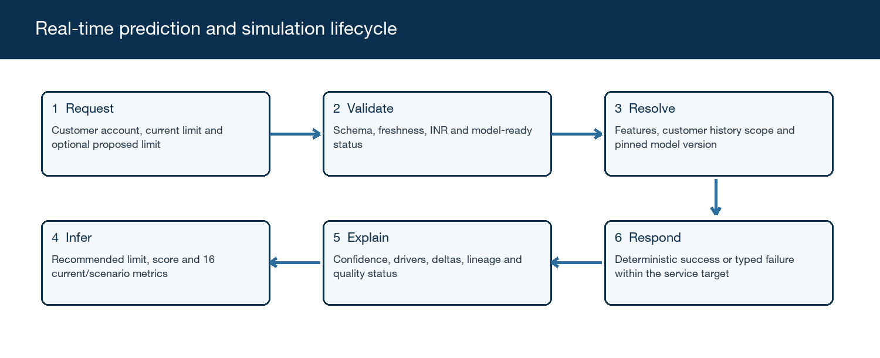
Figure 2. Real-time prediction and proposed-limit simulation lifecycle
1. Inebura submits the current ERP customer account context and, for simulation, an optional proposed credit limit.
2. The service validates the contract version, identifiers, INR currency, timestamps, feature completeness and freshness.
3. The service resolves the approved current-client and matched same-customer feature package and pins one model version for the complete request.
4. The model calculates the recommended limit, current score and all current-scenario outputs. If a proposed limit is present, it calculates a second scenario using the same evidence.
5. The service constructs confidence, drivers, metric deltas, data-scope counts, quality flags and version metadata without exposing another client.
6. The service returns one deterministic success payload or a typed failure. It does not persist the administrator's decision.

9. Real-time API Contract

9.1 Endpoints
Endpoint | Purpose | Required behavior
POST /v1/credit-limit/predict | Return the recommended limit, current scenario and optional proposed-limit scenario | Read-only, authenticated, validated, deterministic for a pinned model version
GET /health | Report process and critical dependency readiness | Must not disclose data, secrets or customer identifiers
GET /metadata | Report supported schema versions, active model version and training date | May be cached; changes only with an approved release

9.2 Prediction request fields
Field | Type | Required | Definition
request_id | UUID/string | Yes | Caller-generated correlation and replay identifier
tenant_id | pseudonymized string | Yes | Current Inebura client context; never returned in explanations
erp_account_id | pseudonymized string | Yes | Account-level scoring key within the tenant
canonical_customer_id | pseudonymized string | Yes | Links the same customer across participating clients
as_of_at | ISO 8601 datetime | Yes | Cuts off all evidence used by the request
currency | enum | Yes | Must equal INR for this release
current_credit_limit_inr | decimal | Yes | Non-negative active limit at as_of_at
proposed_credit_limit_inr | decimal | No | Non-negative what-if amount; does not change stored state
feature_schema_version | string | Yes | Version of the model-ready input contract
account_features | object | Yes | Approved current-client model-ready feature set
matched_history_features | object/array | Yes | Same-customer aggregate across participating clients; source identities excluded
data_quality | object | Yes | Freshness, completeness, conflict and lineage indicators

9.3 Prediction response fields
Field | Type | Definition
status | enum | OK or a typed no-score/error status
request_id | string | Echoed correlation identifier
recommended_credit_limit_inr | decimal/null | Exact model output; null unless status is OK
current_scenario | object/null | Current limit, score, model risk band and all sixteen metrics
proposed_scenario | object/null | Returned only when a proposed limit was supplied
confidence | object | Numeric confidence, label and low-confidence reasons
top_drivers | array | Positive and negative factor name, direction, contribution and plain-language explanation
data_scope | object | Current and other-client observation counts and date ranges only; no source identities
quality_flags | array | Missing, stale, conflicting, imputed or outlier indicators
model_version | string | Immutable inference model version
feature_schema_version | string | Input feature contract version used
output_schema_version | string | Response contract version
prediction_as_of_at | datetime | Evidence cutoff used for the result
generated_at | datetime | Service generation time

9.4 Illustrative request
{
"request_id": "5c1d...",
"tenant_id": "tn_a91...", "erp_account_id": "acct_314...",
"canonical_customer_id": "cust_8f0...",
"as_of_at": "2026-09-10T00:00:00Z", "currency": "INR",
"current_credit_limit_inr": 2000000.00,
"proposed_credit_limit_inr": 2500000.00,
"feature_schema_version": "1.0",
"account_features": { "...": "model-ready values" },
"matched_history_features": { "...": "same-customer aggregate" },
"data_quality": { "is_model_ready": true, "latest_record_wins_applied": true }
}

9.5 Illustrative response
{
"status": "OK", "request_id": "5c1d...",
"recommended_credit_limit_inr": 2374681.25,
"current_scenario": { "credit_limit_inr": 2000000.00, "credit_score": 68.4, "metrics": [...] },
"proposed_scenario": { "credit_limit_inr": 2500000.00, "credit_score": 71.2, "metrics": [...] },
"confidence": { "value": 0.82, "label": "HIGH", "reasons": [] },
"top_drivers": [{ "factor": "on_time_payment_ratio", "direction": "POSITIVE" }],
"model_version": "clm-2026.09.1", "feature_schema_version": "1.0",
"output_schema_version": "1.0", "prediction_as_of_at": "2026-09-10T00:00:00Z"
}

9.6 Typed statuses
Status | Meaning | Retry and consumer behavior
OK | Prediction completed | Do not retry unless evidence or scenario input changes
INSUFFICIENT_DATA | Approved minimum evidence threshold was not met | Do not retry until new data is available; return threshold failures
INVALID_INPUT | Schema, identifier, currency, value or timestamp validation failed | Correct the request; no automatic retry
STALE_DATA | Evidence exceeds the approved freshness threshold | Refresh features before retrying
UNSUPPORTED_SCHEMA | Feature or output contract version is unsupported | Route to integration remediation
MODEL_UNAVAILABLE | Model or critical dependency could not produce a valid result | Safe retry may occur within the request budget; no proposed-limit result may be treated as valid

10. Consistency, Failure and Replay
Scenario | Required behavior | Reason
Repeated request | Same validated payload and pinned model version return the same values; request_id remains traceable. | Supports audit, dispute analysis and regression testing
Duplicate source records | Use the record with the latest authoritative update timestamp and retain conflict lineage. | Implements the approved latest-record-wins rule
Proposed limit below outstanding | Score and all impacts must still be returned when the amount is valid; utilization may exceed 100 percent. | The model informs the administrator rather than enforcing UI policy
Negative or malformed limit | Return INVALID_INPUT and no prediction. | Prevents undefined scenario behavior
Model timeout | Return MODEL_UNAVAILABLE after the bounded retry budget; never return a partial success as OK. | Inebura may display its last valid score but cannot treat the new scenario as scored
Mid-request deployment | Complete the request against the model version pinned at validation time. | Prevents mixed-version outputs
Replay after deployment | Replay must specify the historical model and schema version or be explicitly labeled as recomputed with the current version. | Preserves comparability

11. Privacy, Security and Model Governance
SG-001 Pseudonymization. The model package and API use pseudonymized tenant, account, customer and transaction identifiers. Direct client and customer names are not required for inference.
SG-002 Tenant confidentiality. Cross-client features may influence the prediction only through the canonical customer match. Outputs, drivers, logs and diagnostics must not disclose another client's identity or reconstruct its invoices, balances or behavior timeline.
SG-003 Purpose limitation. Training and inference data may be used only for the approved credit-limit prediction purpose and only for participating clients covered by Tanserv controls.
SG-004 Secure handling. The delivered service must support authenticated transport, encrypted storage, externally supplied secrets and restrictive logging. Credentials must not be embedded in code, images or model artifacts.
SG-005 Model traceability. Every response records model, feature and output-schema versions, as-of time and quality status. Training runs must record code revision, data snapshot, parameters, metrics and artifact checksum.
SG-006 Explainability. Driver explanations must be faithful to the model, stable enough for operational use and free of other-client identifiers. Generic labels such as cross-client payment consistency may be used.
SG-007 Bias and segmentation. Validation must report performance by participating client and other material business segments where sample size permits, without weakening data confidentiality.
SG-008 Human decision. The recommended limit and score remain advisory. Inebura must retain the administrator's final decision separately so later model evaluation can distinguish model output from human action.

12. Validation and Acceptance
Before pilot deployment, the external model team must propose measurable thresholds for discrimination or ranking quality, calibration, eligible-account coverage, stability, segment performance and confidence reliability. Tanserv Product and Risk must approve the thresholds. A model that does not meet an approved launch gate cannot be promoted solely because the API integration succeeds.
ID | Test scenario | Acceptance result
VA-01 | Current-client-only eligible account | Recommended limit, score, confidence, drivers and all sixteen current-scenario metrics return with valid versions
VA-02 | Same customer across participating clients | Combined evidence is used; current-client context remains represented; no source-client detail is exposed
VA-03 | Insufficient relationship history | INSUFFICIENT_DATA returns with failed evidence thresholds and no score or limit
VA-04 | Limit increase | Current and proposed scenarios use identical evidence and model version; all metric deltas are complete and correctly signed
VA-05 | Limit decrease below outstanding | Valid scenario returns, utilization can exceed 100 percent and risk movement is explained
VA-06 | Latest duplicate record | Only the latest timestamped value affects the prediction and the conflict remains in quality lineage
VA-07 | Stale data | STALE_DATA returns according to the approved freshness threshold
VA-08 | Extreme and invalid values | Valid extremes are bounded and explained; negative, non-finite and malformed values return INVALID_INPUT
VA-09 | Deterministic replay | Repeated inputs with the same versions produce numerically identical output
VA-10 | Version mismatch | UNSUPPORTED_SCHEMA identifies the unsupported feature or output version
VA-11 | Timeout or dependency failure | MODEL_UNAVAILABLE returns without a misleading partial success
VA-12 | Confidentiality challenge | Responses, explanations, telemetry and logs contain no other-client identity or raw relationship data
VA-13 | Latency and load | At least 95 percent of complete prediction calls finish within five seconds at the agreed pilot load
VA-14 | Fresh-model comparison | Champion and candidate reports show approved quality, stability and segment gates before promotion

12.1 Model validation evidence
• Time-based holdout evaluation that prevents future information from leaking into training features.
• Comparison against a documented baseline such as the current limit or a simple historical rule.
• Calibration and score-band analysis showing what observed repayment behavior corresponds to each score range.
• Performance and confidence coverage by client and material segment, with sample-size warnings.
• Sensitivity and scenario tests for increases and decreases in proposed limits.
• Feature leakage, target leakage, duplicate-customer and cross-client confidentiality checks.
• Documented threshold proposal and Product and Risk approval for pilot use.

13. Handover and Operational Readiness
Deliverable | Required contents | Exit evidence
Training pipeline | Source, configuration, deterministic preprocessing, experiment tracking and a reproducible training command | Fresh environment reproduces the approved candidate within documented tolerance
Inference service | Tanserv-deployable container implementing predict, health and metadata endpoints | Contract, security, latency and failure tests pass
Feature definitions | Versioned source-to-feature logic, units, windows, missing-value handling and leakage controls | Independent feature reconciliation passes on the acceptance dataset
Model artifacts | Versioned artifact, checksums, runtime dependencies and compatibility matrix | Artifact loads and serves without external-team infrastructure
Validation report | Dataset windows, targets, metrics, calibration, segment results, limitations and approved thresholds | Product and Risk sign-off recorded
Automated tests | Unit, schema, integration, regression, deterministic replay, security and performance tests | All required suites pass in Tanserv CI
Documentation | API specification, model card, data dictionary, deployment, monitoring, rollback and troubleshooting guides | Tanserv walkthrough and knowledge-transfer review completed
Retraining runbook | Data cut, quality gate, training, comparison, approval, release and rollback sequence | Tanserv completes one supervised retraining rehearsal

13.1 Operational signals
Signal | Initial service objective or alert | Owner | Launch gate
Prediction success | Measure OK, no-score and failure rates separately; page on sustained unexpected service failures | Tanserv Platform | Required
Latency | 95 percent of complete calls within five seconds at approved pilot load | Tanserv Platform | Required
Data freshness | Alert when model-ready evidence exceeds the approved freshness threshold | Tanserv Data | Required
Score distribution | Monitor shifts by client, model version and confidence band | Tanserv Model Ops | Required
Model drift | Use the approved feature and prediction drift thresholds; escalate before retraining or promotion | Tanserv Model Ops | Required
Confidentiality | Zero tolerated other-client identity or raw relationship detail in response and logs | Tanserv Security | Required
Rollback readiness | Previous model artifact and routing configuration remain deployable | Tanserv Platform | Required

14. Controlled Pilot and Rollout
The first release will be exposed to one Tanserv-approved client as a controlled pilot. Predictions may inform administrator decisions, but pilot reporting must retain the recommendation, score, scenario shown and final administrator-selected limit as separate records. This allows business evaluation without treating the model recommendation as an automatic decision.
Milestone | Deliverable | Exit criteria
M1 | Data and feature readiness | Model-ready schema, canonical matching, latest-record precedence and quality tests approved
M2 | Offline model validation | Approved model-quality thresholds met; leakage, privacy, reproducibility and explanation reviews passed
M3 | Tanserv-hosted integration | Container, API contract, security, deterministic replay and five-second latency target pass
M4 | Controlled client pilot | Pilot monitoring active; no unresolved critical confidentiality, data-quality or service defects
M5 | Handover and broader-rollout decision | Tanserv retraining rehearsal passes and Product, Risk, Security and Platform approve promotion

Rollback requirement. Tanserv must be able to route inference to the previously approved model version or disable model-backed simulation. A rollback must not alter stored customer limits or historical prediction records.

15. Dependencies, Decisions and Assumptions
Item | Agreed position | Owner or dependency
Currency | INR only; the model returns the exact numerical amount without operational rounding | Product decision
Scoring unit | Per ERP customer account, with optional legal-entity rollup outside the model response | Tanserv data mapping
Cross-client evidence | Same canonical customer only; no peer-cohort requirement | Tanserv identity and participation controls
Input preparation | Tanserv supplies normalized and quality-approved model-ready data | Tanserv Data Engineering
Conflict resolution | Latest authoritative timestamped record wins and lineage remains available | Input contract
Prediction horizon | Ninety days for scenario metrics and dynamic score | Product decision
Minimum history | External team proposes a validated threshold; Tanserv approves before pilot | Model validation dependency
Quality thresholds | External team proposes numerical gates for approval by Product and Risk | Model validation dependency
Service | Real-time API only, hosted by Tanserv; 95th percentile within five seconds | Tanserv Platform
Operation after handover | Tanserv owns retraining, deployment, monitoring and rollback | Handover requirement
User decision | Model output is advisory and does not apply or approve a limit | Inebura integration boundary

16. Glossary
Term | Definition
Canonical customer ID | Pseudonymized identifier used to match the same customer across participating client relationships
Current client | The client and ERP account for which Inebura requested the prediction
ERP customer account | The account-level unit that receives one limit, score and prediction history
Credit score | Dynamic 0 to 100 model output representing combined ninety-day repayment safety under an evaluated limit
Recommended credit limit | The model's exact INR estimate of a prudent limit; advisory rather than automatically effective
Scenario | Prediction evaluated using either the current limit or an administrator-entered proposed limit
Model-ready data | Normalized, quality-checked, versioned input approved by Tanserv for training or inference
Observed | A value directly present in the approved evidence as of the request cutoff
Derived | A deterministic value calculated from observed or predicted fields
Predicted | A model estimate for the ninety-day horizon and therefore subject to uncertainty
PTP | Promise to pay
DSO | Days sales outstanding
Model drift | A material change in input patterns, predictions or observed model performance after deployment

17. Decision and Next Steps
Proceed with the external model engagement using this FRD as the business and interface baseline. The external team must first confirm the model-ready schema, target and feature definitions, then propose measurable quality and minimum-history thresholds. After offline validation, Tanserv will host the delivered service and expose it to one approved pilot client. Wider rollout requires completed handover, accepted model and API gates, confidentiality review and a tested rollback path.

Use footnotes for definitions, assumptions, or terms that need precision without interrupting the main narrative.

